ACKNOWLEDGEMENTS

***In Loving Memory Of***

**James William Rhodes**

.

In this hour of bereavement, we, the family, wish to  
acknowledge with deepest gratitude and appreciation the  
 prayers, visits, cards, flowers and all the words of love and  
encouragement we received. A Special Thank You to Rev. Rogers for being available when needed…

***Honorary Pallbearers***

Marvin Rhodes Charles Butler Jr.

Daryl Russell Warren Kimbrough

Tyrone Rhodes Gary Rosser

Kelvin Butler Glenn Rosser

**Flower Bearers**

Deborah Eisom Patricia Rosser

Veronica Walker Angela Butler

Francine Power Annette Washington

Shelila Butler Betty Jean Rosser

**Arrangements Entrusted to:**

**Herb Walker Funeral Service**

The Final Tribute. A program Service by:

Mary Stevenson Southwestern Registry

675 N-Deis Drive Suite 256

Fairfield, Ohio 45014

(1877) 748-7571

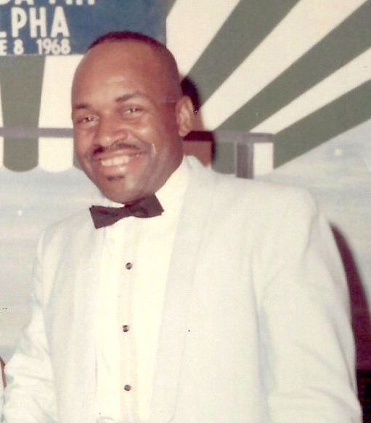

# **Saturday February 7th, 2015**

# **Memorial Service 2:00pm**

# **Second Baptist Church**

# **6225 Betts Avenue**

# **Cincinnati, Ohio 45224**

# **Rev. Roy Rogers Officiating**

Organ Prelude The Musician

Opening Selection Choir

Scripture and Prayer Rev. Henry Rhodes

Military Honor Military Honor Guard

Solo Marie Murray

Acknowledgements and Resolutions

Words of Comfort Ministers

Remarks

The Moments of Meditation Reading Obituary

The Eulogy Rev. Roy Rogers

Benediction

February 1, 2015, God Whispered to "Little Bro, it's time to come

Home. James William Rhodes, was born the third child to the union

Of Jack and Wilhelmena (Thompson) Rhodes on August 26, 1937.

He attended Steele Elementary and North College Hill High School's.

Brother accepted Christ at an early age, and was baptized by his

Uncle at New Life Missionary Baptist Church.

He served in the US Army after leaving school, and was stationed

At Fort Knox, Kentucky and Korea. Before he was honorably

Discharged. After leaving the Service, he moved to Chicago, Illinois,

Where he lived for many years. He was united in Holy Matrimony

To Rosie Lee Johnson (who proceeded him in death.)

Brother moved back to Cincinnati in 2000, and spent the last 14

years, with his Companion Betty Wilson, until his "Home Going."

He was preceded to Glory, by his Parents and Sister's;

Willa Mary (Charles) Butler and Alzada (BJ) Rosser.

Brother leaves to cherish his memory: his Companion Betty Wilson, Sister Jerrileane Rhodes, Nephew Marvin, 13 other nieces and nephews,

Members of the Wilson Family, and many Great, Great-Great

Nieces, nephews and cousins.

Sweet Dreams Brother, We'll see you in the Bye and Bye.

Obituary

 Order of Service

Sweet Dreams Brother, We'll see you in the Bye and Bye

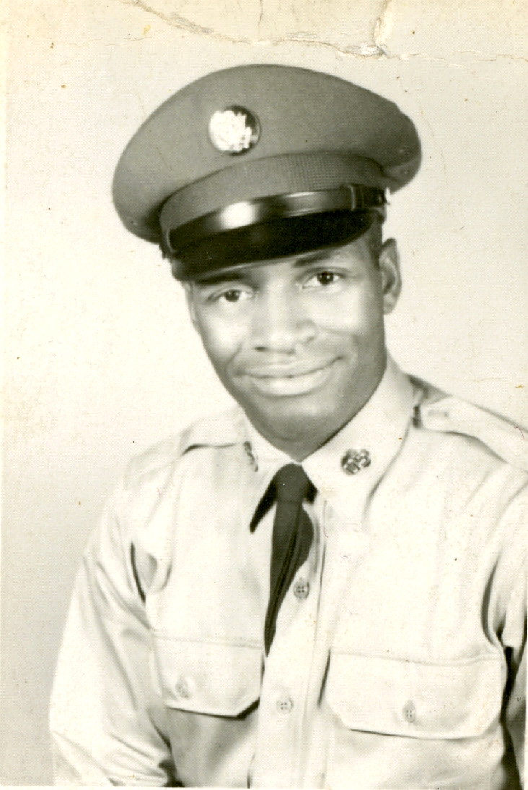

I am the Resurrection and the life, he that believeth in me, though he were dead, yet shall he live; and whosoever liveth and believeth in me shall never die. St. John 11:25-26

I needed the Spirit, so He drew me near, into the shadows where we could confide; away from the hustle of all the day long. While smiling and laughing when active and strong I needed the quietness, though at first I rebelled. But gently, so gently my cross he upheld. He whispered so sweetly of Spiritual things. Though weakened in body my Spirit took wings to heights never dreamed of. He loved me and so gently and quickly drew me away. I needed the quiet, no prison of the bed. But a beautiful Valley of Blessing's instead. A place to grow richer in Jesus. I needed the quiet, so he took me aside.

