***Acknowledgement***

***The family of Steele, O’Neal, and McLean Family would like to thank everyone for the flowers, kind words, prayers and cards extended to them during their hour of bereavement.***

***Pallbearers***

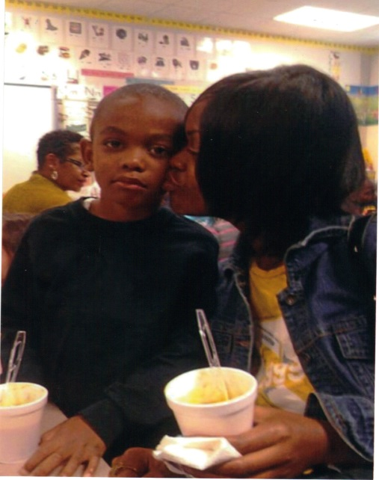***Family and Friends***

***MATTHEW 19:14***

***BUT JESUS SAID, SUFFER LITTLE CHILDREN,***

***AND FORBID THEM NOT, TO COME UNTO ME: FOR OF SUCH IS THE KINGDOM OF HEAVEN***

A Service of Memory

***The Final Tribute. A Service by:***

***Southwestern Registry***

***www.southwesternregistry.org***

***(1877) 748-7571***

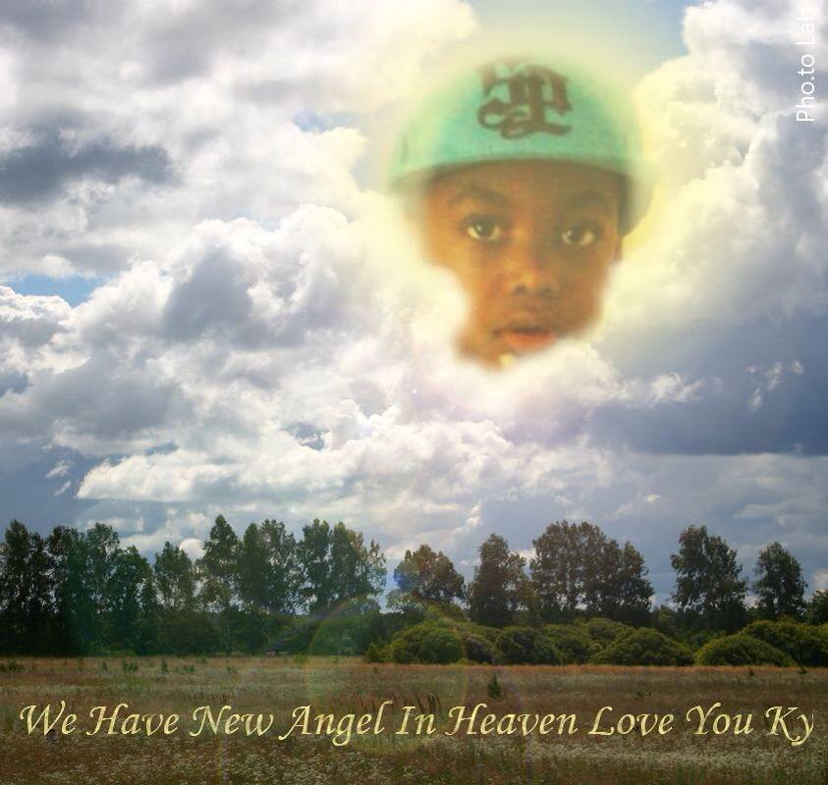

Celebrating the Life of

***KYRAIL J. McLEAN***

***Sunrise***

***February 10th, 2006***

***Sunset***

***August 2nd, 2013***

Obituary

Kyrail McLean was born on February 10th, 2006 to Sherena Steele and Victor McLean Jr. Kyrail attended Shaw University Early Childhood Development Center as a Toddler and then went on to attend Wildwood Forest Elementary. Kyrail loved school and sports mainly basketball. Miami Heat was his favorite team. He loved to play Monopoly, other board games and his video games with his mom and uncles. To all who met and knew Kyrail he was such a

Smart, intelligent and well- mannered young man who loved his mother and family. His nick name was “Lil Obama”. Kyrail and his uncle “Tye” became soldiers in God’s Army on August 2, 2013. He will truly be missed by all who knew and loved him. Kyrail leaves to cherish in loving memory his mother Sherena Steele, his father Victor McLean both of (North Carolina), Grandparents: Janice L. Steele, Renee McLean, Victor McLean Sr. (North Carolina), Oliver G. Steele Sr. (Cincinnati, Ohio), Great Grandparents: Tommy and Charity ONeal, William Steele (Norma Steele Proceeded) (Cincinnati, Ohio), Siblings: Kaylee, Kywren, Kaelan, Jordan and Xavier, and a Special God sister Da’Mya King all of (North Carolina). Aunts: Sheronda McLean, Markita McLean, Crystal McLean, Natasha McLean and Special Aunts Domonique and Devosha King all of (North Carolina). Uncles: Oliver G. Steele Jr., Steve B. Hines Jr., Marcus McLean, Marlon McLean, Shandon McLean, Cameron McLean all of (North Carolina). Great Aunts Tanja ONeal, Catonia ONeal, Brilliantine ONeal, Theresa Spain Carol Steele, Carolyn Curtis (Donnie), Rena Noble (Mark), (Cincinnati, Ohio). Great Uncles: Tommie ONeal Jr., Clevester Steele, Michael Steele, Sammy Steele, Robert Grove (Sharon), all of (Cincinnati, Ohio).

And a host of family, friends, and relatives.



In Memory of

KYRAIL

|  |
| --- |
| I Will Keep my memory with you, For memories never die;  I will see you, When I look across the sky.  I will see you in the clouds, In the birds that fill the air;  In the beauty of a fragrant rose, You will find my memory there  Grandpa (AKA) Pokey |

(As Grandpa always said I gotcha)

*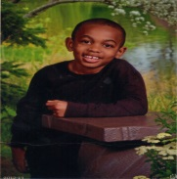**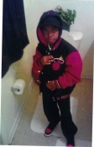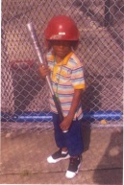*

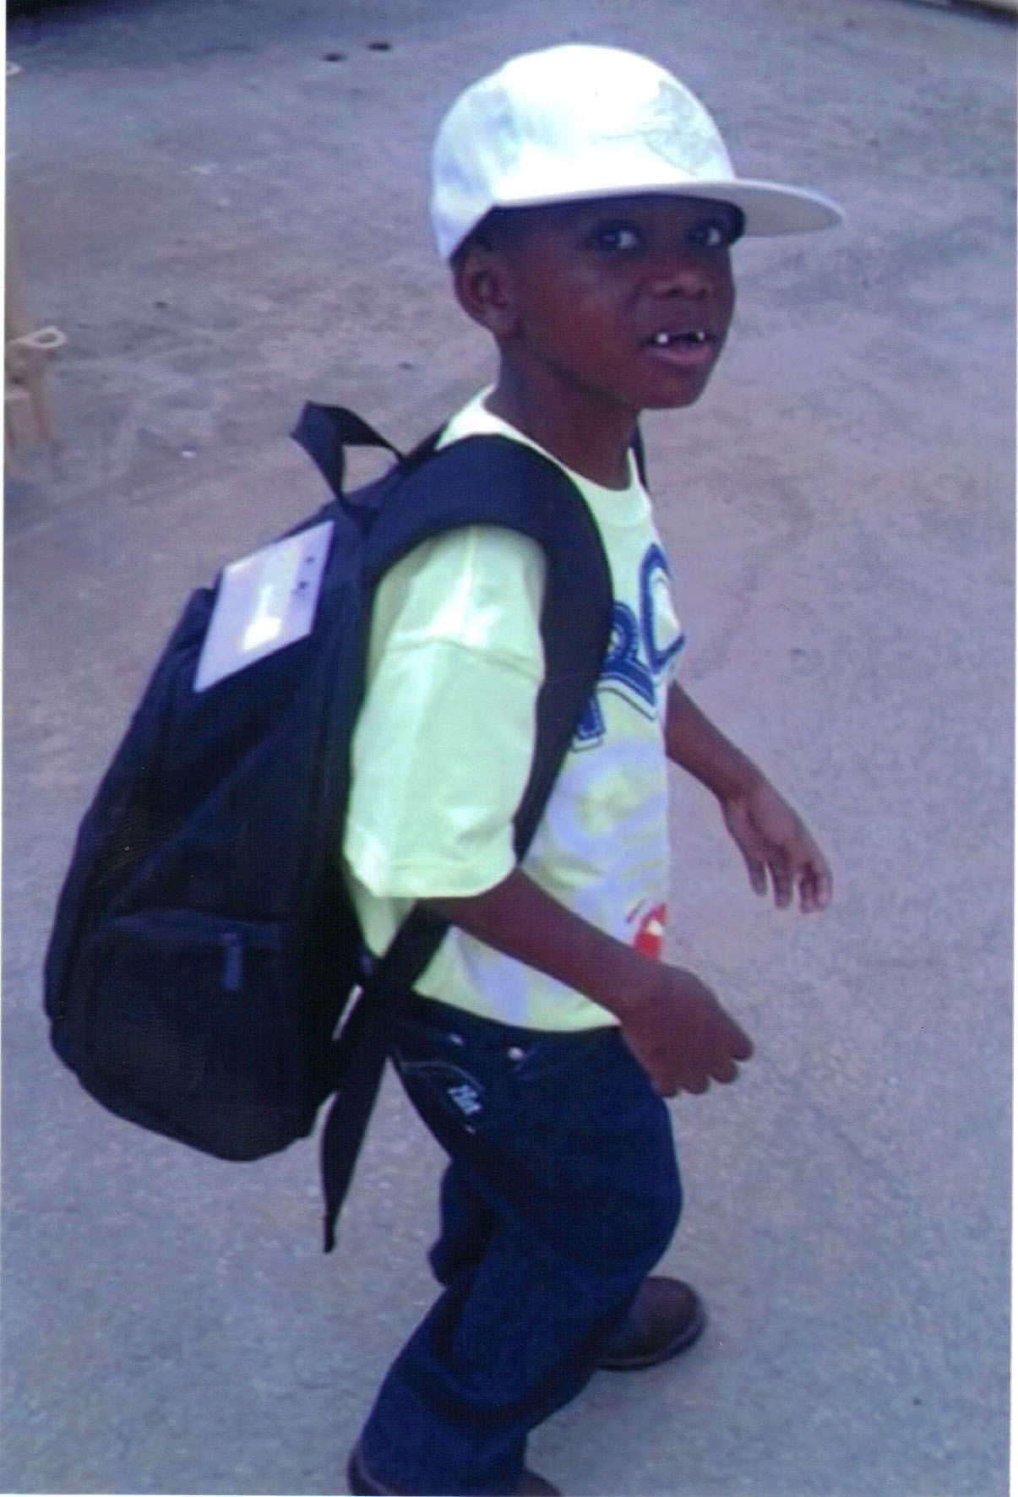

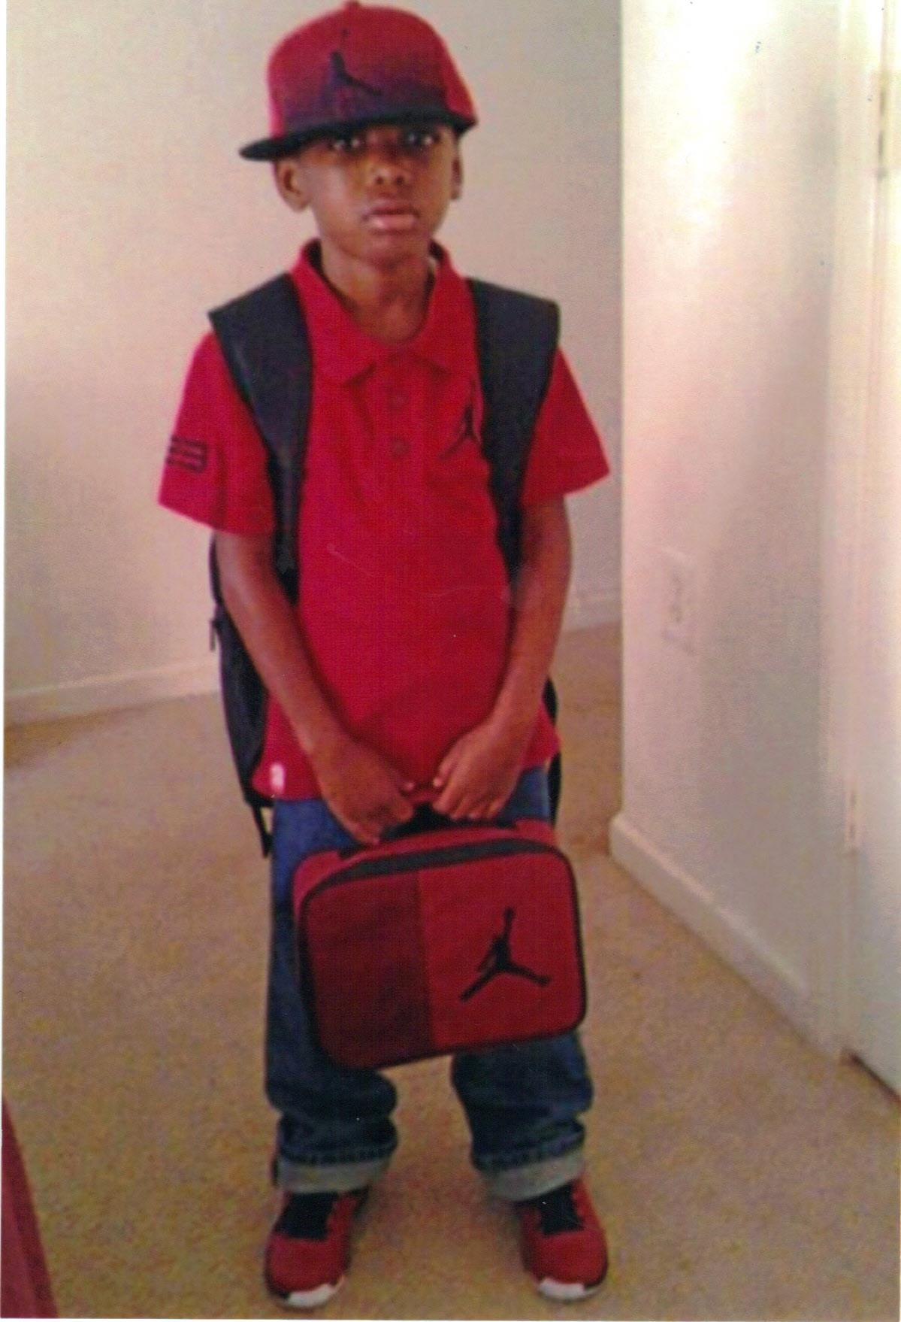

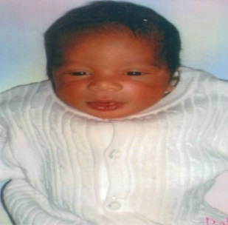

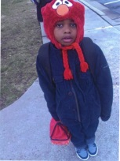



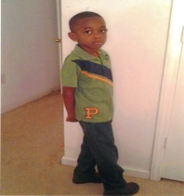

A Message from Grandma Janice

To My Grandson Kyrail J. McLean… Grandma hate to say Goodbye but the Love we share will never die. I will hold you in my Heart forever and I know one day we will be together again but for now rest in peace in your new home with God

*Love you KY*

[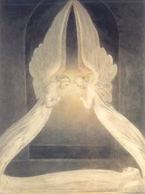](http://www.google.com/url?sa=i&rct=j&q=&esrc=s&frm=1&source=images&cd=&cad=rja&docid=NKI3-aPDcj3TpM&tbnid=ckkNB64JSiqabM:&ved=0CAUQjRw&url=http://www.ascensionearth2012.org/2013/05/message-from-angels-share-your-gifts.html&ei=OugKUtDnDc2WyAHbkIF4&psig=AFQjCNGDgw5nxX4S08FZGRhhEW4NUi54EQ&ust=1376532858943611)*Grandma Janice*